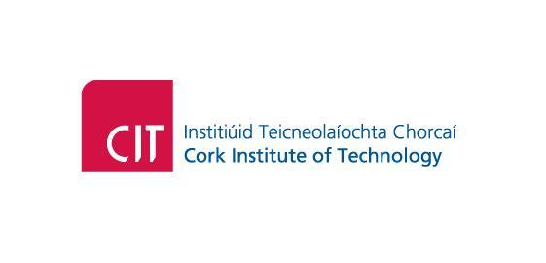

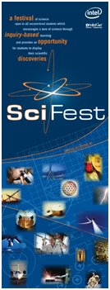

**SciFest 2012**

**PROGRAMME**

|  |  |  |
| --- | --- | --- |
| **9.00**  **9.30**  **10.00**  **12.00**  **1.00 p.m.**  **2.15 p.m.**  nce-mstl logoBTIntel Logo 1700 | **Registration and Set-up in the Nexus**  **Opening Ceremony by Mr. Seán Sherlock,  Minister for Research and Innovation**  **Judging Commences**  **Lunch for Competitors and Teachers**  **Science Talks & Science Show: - IT3 Dr. Hugh McGlynn, - Science in CIT**  **Science Show – Mr. Tony Galvin**  **Science Talks – IT2**  **Dr. Brendan O’Connell, Science in CIT. Dr. Siobhan O’Sullivan – Cracking the Code – The Story of DNA**  esero_IRL_flag+sign**Prize Giving & Closing Ceremony**  DSE logo  flashing Abbott-Button  http://profile.ak.fbcdn.net/hprofile-ak-ash2/50502_292707053344_3468245_n.jpg[EPA - Environmental Protection Agency](http://www.epa.ie/)  PCI Logohttp://tbn3.google.com/images?q=tbn:T2Tnw5CjT-N25M:http://www.scifest.ie/images/Discover%2520Sensors1.png |  |